Document Authorization:

 | Name | Date | Signature
Owner |  | 11Mar2024
Operation Management |  | 11Mar2024
Quality Assurance |  | 11Mar2024

Changes from previous version:

Section | Summary of Changes | Change Control Number
ALL | - New document

- PURPOSE
This document describes the process for creating FedEx label from web portal.
- SCOPE

- INTERNAL REFERENCES
Document ID | Title
QA001 | Quality Policy
SC001 | Electronic Export Information Shippers Export Declaration Filing
- EXTERNAL REFERENCES
Document ID | Title
15 CFR 30.36-31 | Code of Federal Regulations
- RESPONSIBILITIES
Job Function and/or Department | Responsibility
All Personnel
- DEFINITION
Term | Definition
AESDirect | (U.S. Census Bureau) Automated Export System
EEI | Electronic Export Information
Harmonized Code | An internationally standardized system of names and numbers for classifying traded products.
ITN | Internal Transaction Number
SED | Shipper’s Export Declaration
- PROCEDURE
  - Domestic shipping
    - Log into FedEx Ship Manager
    - Step 1: Select Create a Shipment
      - Make sure the drop down at the top is set to Outbound Shipment. Other shipment types include:.
        - Outbound – default selection for most of the ship label creation
        - Import (rarely used)
        - Return
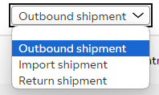
    - Step 2: Select Shipment Profile.
    - If we have shipped to this customer before,and a shipment profile was saved, select from the shipment profile. You can also search for past shipments under the “Shipments” tab and select repeat. Both of these options will auto populate most of the fields in the next steps. Double check all the populated fields in the next steps and make sure to update the reference # and customer PO (if applicable). If this is the first-time shipment to this customer, then skip this step.
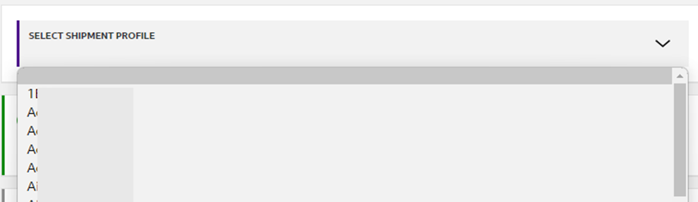
    - Step 3: Ship From. Make sure the Ship From address information is correct. For outbound shipment, select Synoligo Shipping from the address book. Check all the fields for accuracy.
-(Only for very first time)Check Save As Default Sender Details box if this is the first time creating a shipment using this address. Check Save as new sender in Central address book box if this is the first time creating a shipment or there is any update.
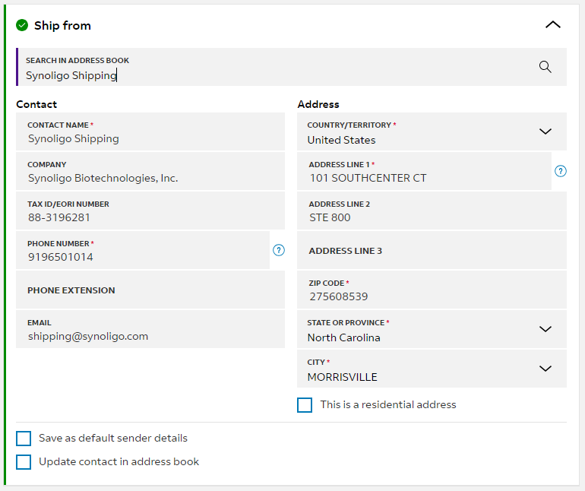
    - Step 4: Deliver To. If this is a preexisting customer and its information was saved before, select from the search box by typing the first three letters of the Contact Name. Otherwise, fill in all the required information. Make sure check Save as new recipients in the Central address book box.
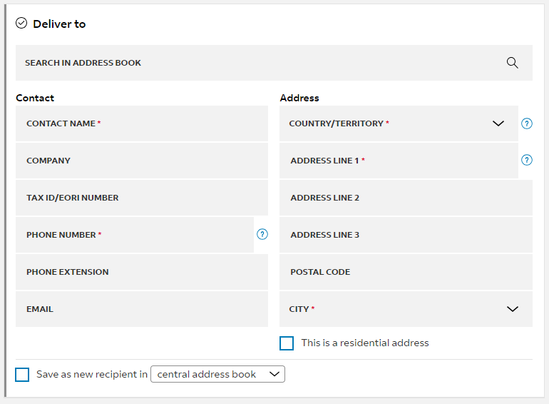
    - Step 5: Package Details. From the dropdown select packaging type (Standard FedEx packaging or Favorite Synoligo packaging). Verify package weight and dimension information. If it’s a custom dimension, there will be option to save this as favorite for future use. If there is dry ice in the package, check Add non-standard packaging, dry ice, or lithium battery box. If an order value is over $10,000, check Purchase a higher limit of liability from FedEx and fill in Carriage Value per Package using 10% of the order value (e.g. if the order value is $150,000, then enter $15,000 as Carriage Value. FedEx only allows up to $50,000 carriage value). Note: All international shipments will require insurance no matter the price.
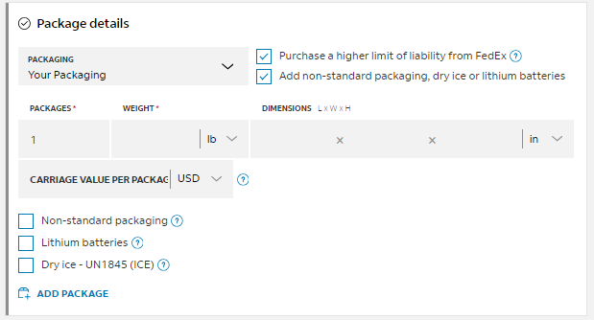
    - Step 6: Service Details. Select ship date and service type. For most of the customer order, select FedEx Priority Overnight.. For additional options, Add references should already be checked, fill in the Sales Order number (S2xxxx) in Shipment Reference field, and fill customer PO in PO No. field, leave blank if no PO.
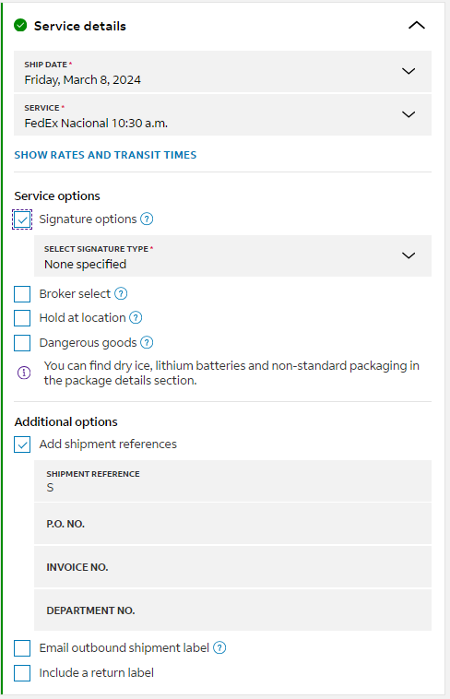
    - Step 7: Pickup/Drop-off.
    - Choose drop down option ”I have scheduled a pickup at my location”. Fedex is scheduled to pick up Monday-Friday between the hours of 5:30pm-7:30pm (excluding major holidays)
      - Note: Fedex Ground has now merged with Fedex Express and scheduled pickups are no longer required for Ground. The driver will now pick up all FedEx packages at once.
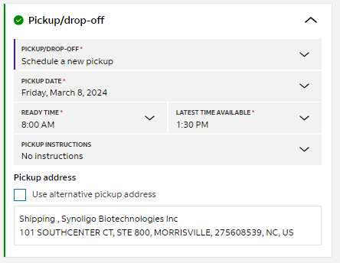
    - Step 8: Billing Details. Select option for “Bill transportation cost to” which are as follows:
      - To My Account - for domestic shipments.
      - Recipient (which often is customer themselves - for international shipments
      - Third Party (This happens when customers choose to ship to a third-party testing facility. In this case, use customer’s FedEx account number).

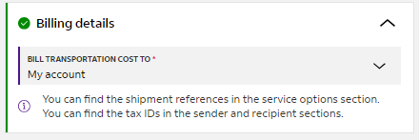
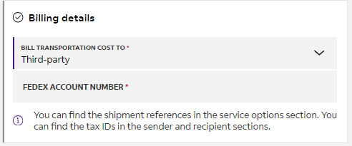
    - Step 9: Add Shipment Notifications. Check Add shipment notification. Add recipient/third-party email address to receive CREATED, ESTIMATED DELIVERAY, DELIVERED notification. Add shipper email address using shipping@synoligo.com to receive CREATED, DELIVERED.
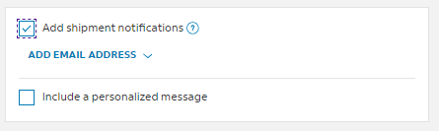
    - Step 10: Verify the final cost of the shipment and the estimated delivery.
    - Step 11: To save time for next shipment, click Save as shipment profile.
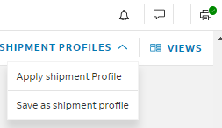
    - Click Finalize and Print to generate the label (If the printer icon has a green check mark, it means the shipping manager is connected to the label printer located in the printing area). Save one copy of the label in pdf format in the order shipping folder.
  - International shipping
    - Follow SC001 to create an ITN number. This step must be taken before generating FedEx label.
    - Step 1-5 are the same as for domestic shipping.
    - Once an international address is filled in, additional options will appear below package details section.
    - Step 6: Package Contents. If the shipment is for a document, select Documents radio button. Otherwise, select Items radio button.
Any saved item can be added in the Search Saved Items box by typing in e.g. “oligo” which is for most of custom oligo order.

Revise as needed by clicking the edit icon. If this is a new item, click Add New Item to add a new item. At the end, check Save as a New Item.
The following information is needed to add an item
- The item description
- HS code
- Made in (origin)
- Quantity
- Weight
- Custom Value.
In Shipment Purpose dropdown, pick Commercial for shipment to customer directly, Sample for Synoligo-selected third party testing facility or customer-selected CRO. Gift is rarely used.
Step 7. Commercial Invoice
In Invoice for Customs dropdown, pick “I want FedEx to create a commercial invoice”. In Terms of Sale field which is usually EXW, fill in the actual value from Order Confirmation document; In Declaration Statement field, fill in “End Use: research use only, not to be used on animal or human subjects. Country of Origin/Manufacture: USA. Manufactured from non-animal source, BSE/TSE free.”. Check Attach Trade Documents Electronically box.
In Additional Documents, upload as needed other documents to facilitate custom clearance.
In Letterhead and Signature, these should already be filled out.
Check The Sold-to Party is Not The Consignee box only if customer instructs shipping to their CRO directly. Pick from Search in Address Book or fill in customer’s information here. If this is a new customer, check Save as New Contact in Central Address Book.
The Originator is Different from the Shipper box is rarely checked.
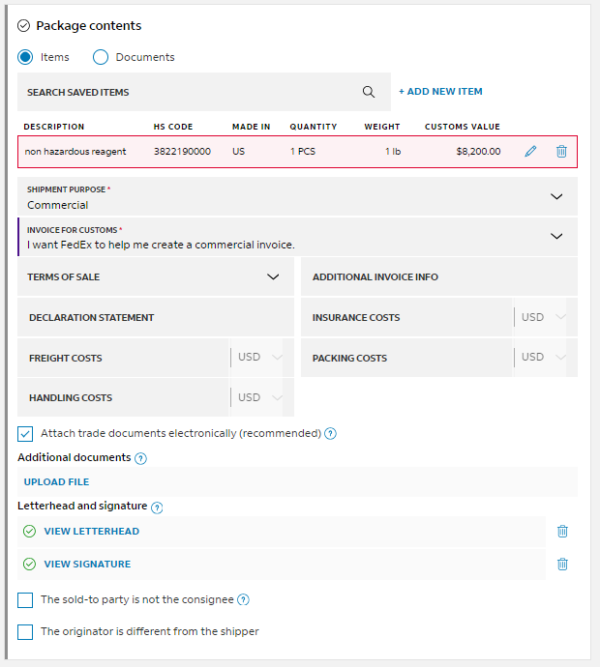
    - Step 8: Electronic Export Information (EEI). If the shipment is to Canada or to other countries valued below $2,500 excluding shipping and tax cost, select No EEI/SED required, select No EEI 30.36 (Canada exemption) and No EEI 30.37(a) (below $2,500 exemption) in FTR Exemption No. Select Department of Commerce for DCS Type.
If EEI/SED is required, select I Have Already Filled or Will Fill Using AES. Select Pre-Departure ITN for AES Citation Type. Fill in AES Citation number generated from SC001. Select Department of Commerce for DCS Type.
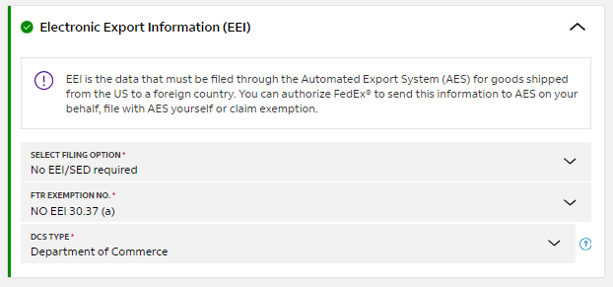
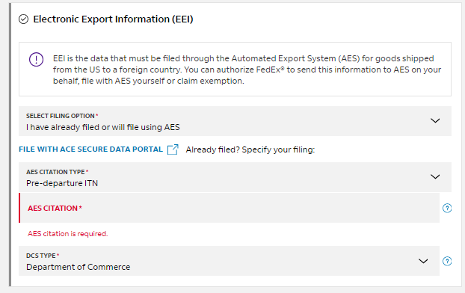
    - Step 9: Service details. Select Ship Date and Service Type. Some clients will request to use a designated Broker. In this case, Under Service Options, check Broker Select. Otherwise leave this unchecked so that FedEx will be default broker for custom clearance. Under Additional Options, fill in Shipment Reference field with Synoligo Order Number or leave blank if ship to non-customer recipients; fill in PO No field with Customer PO No. for customer order or Synoligo PO number for Synoligo-selected testing facilities or leave blank for all others.
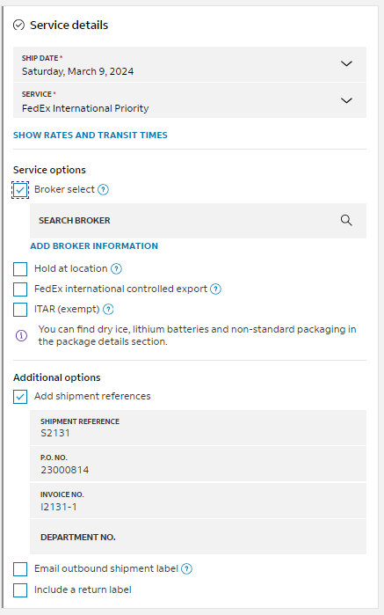
    - Step 9: Pickup/drop-off. Select the corresponding options as needed.
    - Step 10: Billing Details. For Domestic shipments, select “my account” for the “Bill Transportation Cost To” field, unless instructed otherwise. For International shipment, select “Recipient” under the “Bill Transportation Cost to” field, unless stated otherwise
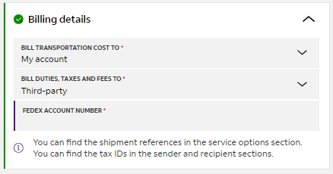
    - Step 11: Add Shipment Notification. Check Add Shipment notification to shipping@synoligo.com and customer’s email.
    - Step 12: Click Finalize and Print.
    - Step 13: On the finalized page, it’ll give you the option to download the transaction record and the commercial invoice. Save these documents to its corresponding order folders and print out the commercial invoice to be attached to the package.

      - If you miss the chance of collecting these documents on the final page, Click Shipments on the navigation panel on the left. Check the shipment just created. A menu bar will appear above the shipment list. Click Print Documents, then Shipping Label, then Print. A small window will appear showing “Successfully Printed the Shipments”.
